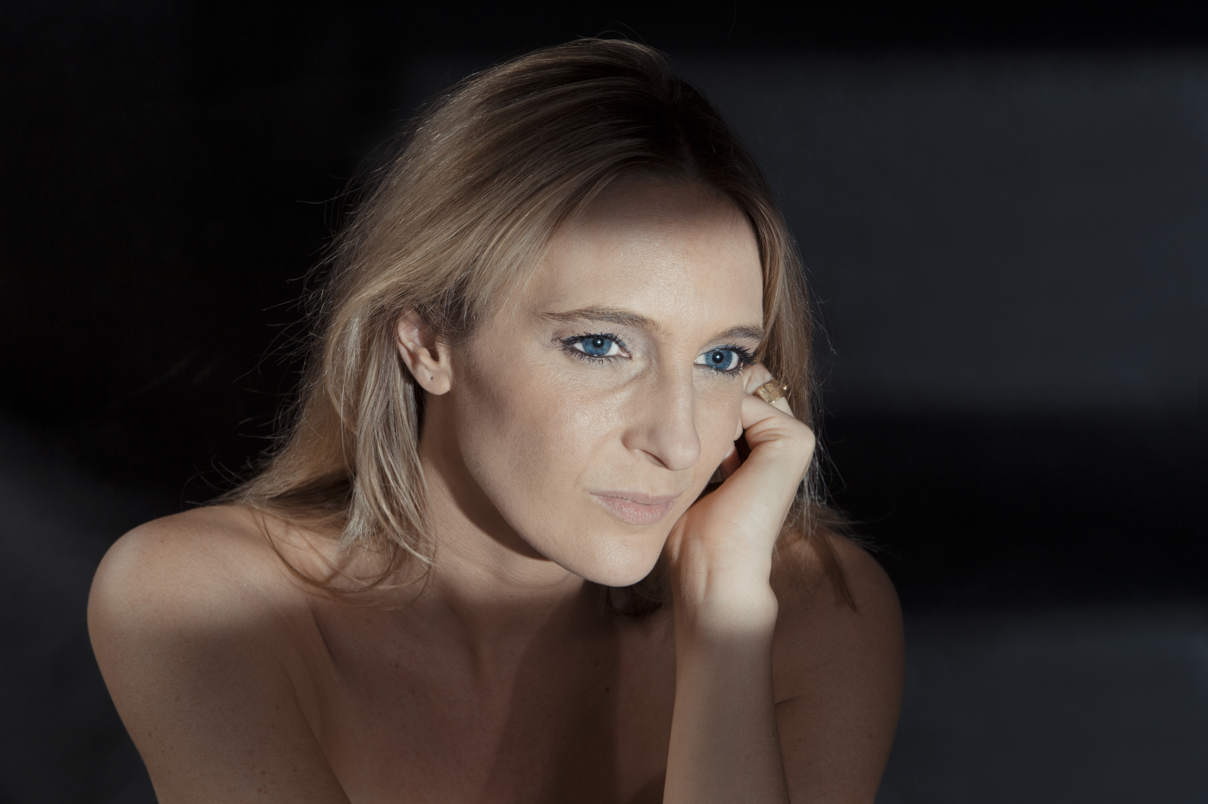
Céline Scheen
Soprano

Céline Scheen completed her training at the Guildhall School of Music and Drama in London, with Vera Rosza, thanks to the support of the Nancy Philippart foundation.

She has performed in the greatest festivals and concert halls, under the direction of Reinhard Goebel, Louis Langrée, Ivor Bolton, René Jacobs, Christophe Rousset, Andrea Marcon, Jordi Savall, Philippe Pierlot, Philippe Herreweghe, Skip Sempé, Jean Tubery, Leonardo Garcia Allarcon…

At the Opera she has interpreted Zerlina in Don Giovanni (G. Corbiau), Coryphee in Gluck’s Alceste (La Monnaie, I.Bolton/B.Wilson), Atilia in Eliogaballo by Cavalli (La Monnaie, Festival d'Insbruck, Jacobs/Boussart), Papagena in Mozart’s Magic Flute (La Monnaie, Caen, Lille, New-York, R.Jacobs/W.Kentridge and Toulouse, C.P.Flor/N.Joël), L'Amour and Clarine in Platée by Rameau (Opéra du Rhin, C.Rousset/M.Clément), La Musica & Euridice in Orfeo by Monteverdi (Cremona, A.Marcon)...

She has recorded, namely the music of the film Le Roi Danse (DG) with Musica Antiqua Köln and Reinhard Goebel, she has worked with Paolo Pandolfo for a CD on improvisations (Diapason d'or); the Orgelbuchlein by J.S.Bach with the ensemble Mare Nostrum (M.A. Recording); "Barbara Strozzi" with La Cappella Mediterranea and Leonardo Garcia Allarcon (Ambronay); Amarante (Flora) with Philippe Pierlot and Eduardo Eguez as well as Bellérophon by Lully with Les Talens lyriques and Christophe Rousset, the secular Italian Cantatas by JS Bach with Leonardo Garcia Alarcon, Monteverdis’s Vespers with the Ricercar Consort and Philippe Pierlot.

During 2012/2013 season at the concert she sings Bach, Graupner, Monteverdi, Rameau, Zelenka with the Ensemble Pygmalion & Raphael Pichon, Le Banquet Céleste & Damien Guillon, La Cappella Mediterranea & Leonardo Garcia Alarcon, Collegium 1704 & Vaclav Luks, la Cetra Basel/RIAS Kammerchor and Andrea Marcon. On stage she was Venus in Venus & Adonis by John Blow in a new production of the Théâtre de Caen which toured at the Grand Théâtre du Luxembourg, Opéra d’Angers et de Nantes, Opéra de Lille, Opéra Comique in Paris and MC2 in Grenoble for not less than 23 performances. The DVD just been released on Alpha – Outhere.

In 2014 Céline Scheen has sung in two new productions of the St Mathew Passion, in Copenhagen with the Danish Radio under the direction of Andrea Marcon, then in Dresden and Prague with the Collegium 1704 under Vaclav Luks. During the season 2015/2016 Céline has appeared with her regular partners, among them Le Banquet Céleste & Damien Guillon in France and Europe as well as L’Arpegiatta & Christina Pluhar in Europe, US and Brazil. In 2017 Céline will tour abroad again with L’Arpegiatta – New York and New Zealand.

December 2016

